Team 6:

* Sajib (180028)
* Amar (180036)
* Bibek (180010)
* Abdul (180030)

**Milestone-1**

1. **Identify the entities and provide a brief description of it for the assigned project.**

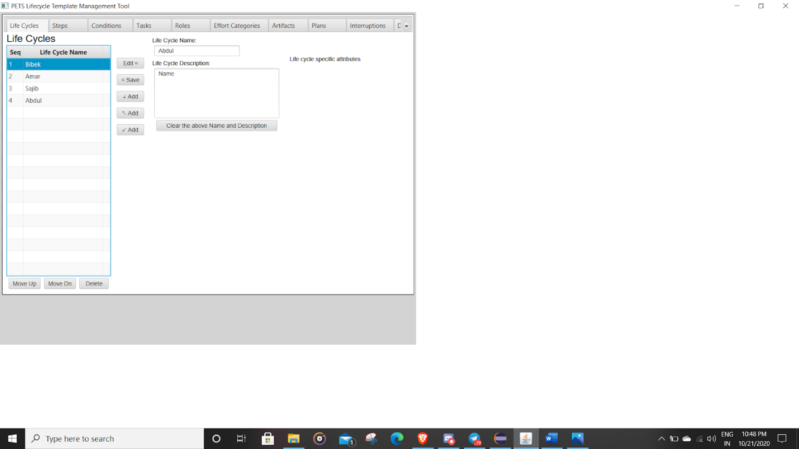

Here is the list of Entities with their descriptions:

1. **Life Cycle**

This tab contains info about the Life Cycles. It has an option to add name and description and they are stored in a table. We can perform edit, save, and add operations in the tab. Along with these, this tab has the following

* TextField is for the name of the life cycle
* Description text field
* Several buttons including creating, save, edit, import, download, clear the names and definition above, upload, and remove.
* We can save the name of the life cycle using the save button.

1. **Steps**

This tab is about the steps in the life cycle. It contains step names and descriptions. It mentions the steps, pre-condition of the life cycle, tasks, post-conditions in the form of a table. We can edit, delete, and add in this as well. Along with these, the tab has the following:

* 3 combo boxes
* Button to save, edit, and CRUD operation
* Text Field and Area
* Task name area and table to store the data.

1. **Conditions**

This tab is for the conditions. It has a table which stores the conditions. The condition contains the name, description, and state of it.

The tab has the following:

* Text area for the long description
* Text field for cycle name
* Buttons including (CRUD, add up, add down, add bottom, clear button)

1. **Tasks**

This tab is about the tasks which were mentioned in the previous tab i.e. Step. There is a table for the added tasks. The task contains names and descriptions. There are two more items that are artifacts used and artifacts produced in the task. Along with these, the tab has the following:

* The text field and text area for the description
* Combo box
* Table to store data and name
* CRUD and Up, Down buttons

1. **Roles**

This tab contains details about the roles. It has the role name and description and is stored in the table. There is also an option to edit, add, and save the role. It also has a text field and a text area to store the name and description of the role. It has 9 keys, editing, saving, adding, adding down, adding down, clearing the name and description above, moving up, moving Down, and deleting.

1. **Effort Categories**

This tab contains details about the efforts. It contains effort category name and description and is stored in the table with edit, add and save options. It also contains artifact options for effort categories. Along with these, the tab has the following:

* Two combo boxes to add artifacts and storing category
* Table to store data of effort, artifact.
* Text area for the long description
* Text field for cycle name
* Buttons including (CRUD, add up, add down, add bottom, clear button)

1. **Artifacts**

It contains details about the artifacts. It has a name and description field and is stored in a table. We can edit, add, and save the artifacts. The tab has a text field and text area to store the name of the artifacts. It has 9 keys, editing, saving, adding, adding down, adding down, clearing the name and description above, moving up, moving Down, and deleting.

1. **Plans**

This tab is about the plans. It has a name and description and is stored in a table. We can edit, add, and save the plans and also clear it. The tab has a text field to enter the name of the artifact and one text area to enter descriptions.

1. **Interruptions**

This tab is about the interruptions. It has a name and description and is stored in a table. We can edit, add, and save the plans and also clear the interruptions. The tab has one test field for artifact name and one text area. It also has a table to store the interruption number.

1. **Defects**

This tab is about the Defects. It has a name and description and is stored in a table. We can edit, add, and save the plans and also clear the Defects. The tab has 9 different buttons including Edit, Save, add up, add down, add bottom, Clear the above name, and description, Move Up, Move Down and delete.

1. **Identify the generalization & specialization hierarchy in the entities.**

From the project and code, we could see that the **ListItemEntry** can be classified as the generalization of all the entities because all entities extend ListItem and share  common attributes that are SequenceNumber, listItemName, listItemDescription.

All the other entities can be considered as specialization because even they inherit the properties of ListItemEntry but their self attributes are unique.

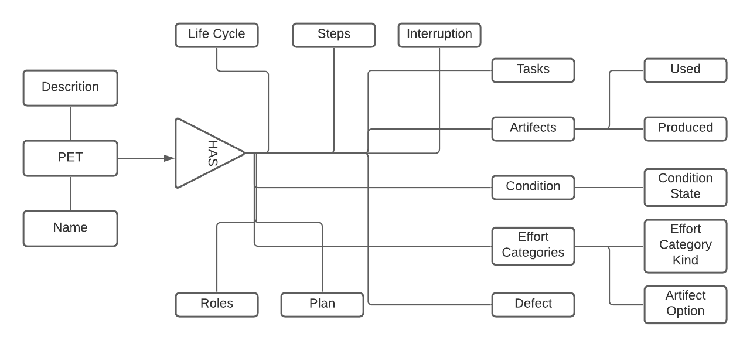

1. **Provide the attributes list for the identified entities.**

|  |
| --- |
| **Lifecycle Entity** |
| Seq.No<Integer PRI>  Name<varchar not null>  Description<varchar not null> |

|  |
| --- |
| **Steps Entity** |
| Seq.No<Integer PRI>  Name<varchar not null>  Description<varchar not null> |

<

|  |
| --- |
| **Tasks Entity** |
| Seq.No<Integer PRI>  Name<varchar not null>  Description<varchar not null> |

|  |
| --- |
| **Condition Entity** |
| Seq.No<Integer PRI>  Name<varchar not null>  Description<varchar not null>  DefaultConditionState <Boolean default> |

|  |
| --- |
| **Effort Categories Entity** |
| Seq.No<Integer PRI>  Name<varchar not null>  Description<varchar not null> |

|  |
| --- |
| **Roles Entity** |
| Seq.No<Integer PRI>  Name<varchar not null>  Description<varchar not null> |

|  |
| --- |
| **Artifacts Entity** |
| Seq.No<Integer PRI>  Name<varchar not null>  Description<varchar not null> |

|  |
| --- |
| **Plan Entity** |
| Seq.No<Integer PRI>  Name<varchar not null>  Description<varchar not null> |

|  |
| --- |
| **Interruptions Entity** |
| Seq.No<Integer PRI>  Name<varchar not null>  Description<varchar not null> |

|  |
| --- |
| **Defects Entity** |
| Seq.No<Integer PRI>  Name<varchar not null>  Description<varchar not null> |

1. **Identity the mapping constraints within the entities.**

Listitem class is used directly by Artifacts, Plans, Interruptions, and Defects tabs.  This class is inherited by the Life Cycles, Steps, Tasks, Conditions, and Effort Categories tabs and additional attributes and user interface elements are added to this base to support those tab specific needs of those tabs.

The mapping constraints used in the projects is one to many as the entity class “listitem” is associated with more than one entity class in the project.

1. **Draw the ER Diagram for the assigned project**

